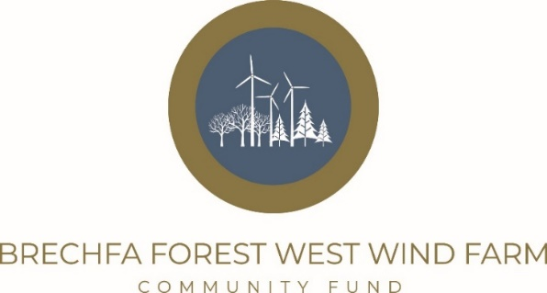

Project Extension Form

Please make sure you fully review the Guidelines for Applicants before you complete this application. Please ensure that you complete all sections. Where a question is not appropriate to your organisation or project please write Not Applicable (N/A)
For Office Use Only:
Reference number…………………………….. Date of receipt……………………………

Section 1: About Your Organisation
Name of organisation
Name of project
(Please note that if the application is successful, the award will be published on the Fund web site)
Contact details of person responsible for the application/project
Name:
Position within organisation:
Address:

Post Code:
Contact telephone:

Email address
Contact details of a second person within the organisation
Name:
Position within organisation:
Address:

Post Code:
Contact telephone:

Email address

Section 2: About Your Project
Please describe the impact and highlight the successes of your project in the Brechfa Fund’s area of benefit. (if you have any photos, quotes or case studies, please attach them to your application)
Explain what your project extension would ideally look like

Are there any amendments or improvements to your current project if extended?
What evidence do you have that your project needs extending?
What projects are you currently working within the Fund’s area of benefit?
Have you applied to other funders for your delivery? Please explain
Is there anything additional that you would like the panel members to know about your project? E.g. quote/case study/photos?
If your request is funded, how do you plan to sustain it in the long term?
If the application requires a contribution towards salary costs, please provide the job specification with your application.
When is the planned project start date? | When is the planned project completion date?

Section 3: Proposed Project Financial Details (If required use an additional page).
Other Grants applied for/received in the last two years (please list)
What will be your organisation’s financial contribution to this project? (volunteer time, financial or other funding?)

Please outline your project cost in the section below (rounding up to the nearest £1 where required.
Item | Cost £
Total Project Cost
Total amount requested from Brechfa Wind Farm Fund

Is your Organisation registered for VAT? (tick appropriate box)  (If yes; you will be expected to reclaim VAT on your project and any grant paid will exclude the VAT element) | Yes | No
 | VAT Number.(if applicable)
How much is your organisation holding in financial reserves?
Can you outline if the funds are being ring-fenced for a specific purpose?
Is your proposed project taking place on NRW land? | Yes/No
If so, who is your contact in NRW
Is your project taking place on Church in Wales property | Yes/No
If so, who is your CIW contact
Does your organisation have a bank account | Yes/No
Have you contacted the Fund Manager to check your project is eligible | Yes/No
Have you supplied the relevant documents that the Fund Manager has requested specific to your application? | Yes/No

To be completed by a representative of the organisation/group:
I confirm that all the information on this form is true and correct.
Representative’s name: | Position:
Phone Number: | E-mail:
Signature: | Date:

Data protection. Antur Cymru/Antur Teifi the administrator of the Fund, complies with the UK GDPR alongside the Data Protection Act 2018. Information provided on this form will be processed by the administrator solely for the purposes associated with the management of the Brechfa Forest West Wind Farm Community Fund.
Please return completed application form and supporting documents to:
Moishe Merry
Fund Manager, Brechfa Forest West Wind Farm Community Fund
Antur Cymru,
Antur Teifi Business Park,
Aberarad,
Newcastle Emlyn,
Carmarthenshire,
SA38 9DB

Or Email to: brechfa@anturcymru.org.uk
For further information/advice please contact Antur Cymru using the above contact details.
Next Steps
- We will confirm receipt of your application.
- The Fund Manager will be in touch to discuss your application is eligible to go to the next panel meeting.
- If your application is going to panel, you may hear from the Fund’s Team if the panel members have any specific areas they seek clarification on.
- You will receive a grant offer letter or decline letter within one month of the panel meeting.
- The panel decision is final, and detailed feedback cannot be provided beyond the letter.
- If your funding request is approved, your offer letter will details the next steps and any potential monitoring requirements from the Fund, along with a grant acceptance form which will need to be completed before payment is made.

