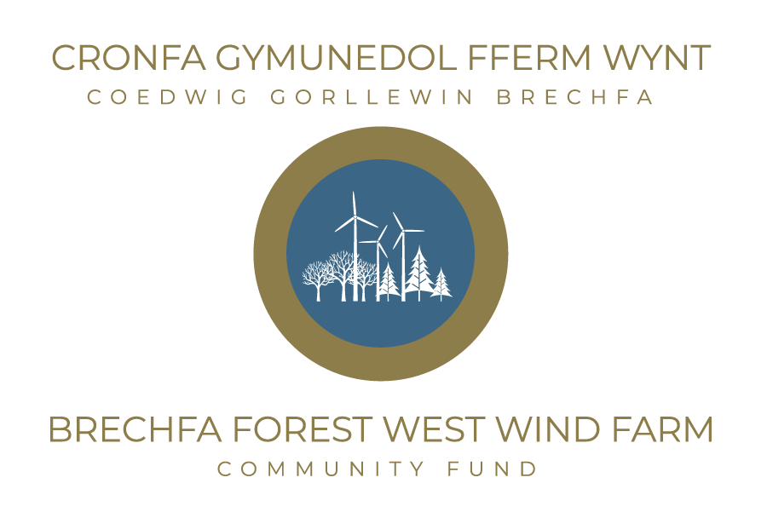

Additional Fund Request Form
Date Received: ..................................... Reference Number:...............
Name of Organisation
Contact Name
Position
Phone number & email
Project Name & Reference Number
Why are additional funds required

Project Financial Details (If required use an additional page).
Other Grants applied for/received in the last two years (please list)
Do you have any other applications pending? If so, please provide a brief summary.
What will be your organisation’s financial contribution to this project? (volunteer time, financial or other funding?)

Please outline your project cost in the section below (rounding up to the nearest £1 where required.
Item | Cost £
Total Project Cost
Amount Applied For

Is your Organisation registered for VAT? (tick appropriate box)  (If yes; you will be expected to reclaim VAT on your project and any grant paid will exclude the VAT element) | Yes | No
 | VAT Number.(if applicable)
How much is your organisation holding in financial reserves?
Can you outline if the funds are being ring-fenced for a specific purpose?
Is your proposed project taking place on NRW land? | Yes/No
If so, who is your contact in NRW
Date Funds required

To be completed by a representative of the organisation/group:
I confirm that all the information on this form is true and correct.
Representative’s name: | Position:
Phone Number: | E-mail:
Signature: | Date:

Data protection. Antur Cymru/Antur Teifi the administrator of the Fund, complies with the UK GDPR alongside the Data Protection Act 2018. Information provided on this form will be processed by the administrator solely for the purposes associated with the management of the Brechfa Forest West Wind Farm Community Fund.
Please return completed application form and supporting documents to:
Moishe Merry
Fund Manager, Brechfa Forest West Wind Farm Community Fund
Antur Cymru,
Antur Teifi Business Park,
Aberarad,
Newcastle Emlyn,
Carmarthenshire,
SA38 9DB

Or Email to: brechfa@anturcymru.org.uk
For further information/advice please contact Antur Cymru using the above contact details.
Next Steps
- We will confirm receipt of your application.
- The Fund Manager will be in touch to discuss your application is eligible to go to the next panel meeting.
- If your application is going to panel, you may hear from the Fund’s Team if the panel members have any specific areas they seek clarification on.
- You will receive a grant offer letter or decline letter within one month of the panel meeting.
- The panel decision is final, and detailed feedback cannot be provided beyond the letter.
- If your funding request is approved, your offer letter will details the next steps and any potential monitoring requirements from the Fund, along with a grant acceptance form which will need to be completed before payment is made.

