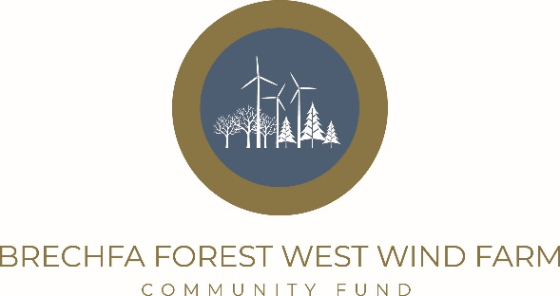

Panel Member Application Form
For reference, the role and responsibility of a Fund Panel Member are set out in the accompanying terms of reference and code of conduct. Please return this form to: Moishe Merry
Postal address-: Antur Cymru, Antur Teifi Business Park, Aberarad, Newcastle Emlyn, Carmarthenshire, SA38 9DB
Or Email to -: brechfa@anturcymru.org.uk
Your Full Name

Address:

Postcode-:
Telephone Number

Mobile Number

Email Address

Please indicate your age bracket | □ Under 20 years old  □ 20 – 39 years old  □ 40 – 65 years old  □ 65+
Panel Members must live, work or volunteer within the area of benefit for the local fund (6km from the wind farm – see map)

Which of the above applies to you?

Please indicate which of the following you are interested in or have specialist knowledge or experience of:
Health & Well being |  | Sports & Exercise
Arts, culture & heritage |  | Young People/Youth Work
Older People |  | Families & young children
Education, training & lifelong learning |  | Local economy & business
Infrastructure, housing, transport & communications |  | Environment
Community Facilities, leisure & recreation |  | Strengthening local groups (capacity building)
Welsh Language |  | Other

Please briefly describe your previous experience of working or volunteering with or for a voluntary or community organisation/group, in what capacity, and the experience you gained:

Please use this section to outline any other experience, skills, or training that you feel may be relevant to the role of a Brechfa Forest West Wind Farm Community Fund Panel member:

If you have any additional or special needs or adjustments that are essential to you fulfilling the role of panel member please state below. Alternatively, contact the Fund Manager, Moishe Merry, directly.

Please supply name and contact number for two references (they should not be related to you)
Name: | Name:
Email address/Telephone number: | Email address/Telephone number:

Declaration: I confirm that the information given by me on this form is correct:
Signed……………………………………………………………….
Date……………………………………………................................
Data Protection: Information provided on this form will be processed by the administrator solely for the purposes associated with the management of the Brechfa Forest West Wind Farm Community Fund.

Panel Member Job Profile
Overview
The Panel is a formal body of volunteers drawn together for the specific purpose of making decisions about the disbursement of funds from the Brechfa Forest West Wind Farm Community Fund.
We are looking to recruit a panel that is representative of the whole community, therefore Panel members may be young or old, working, retired or unemployed and from a wide range of backgrounds. The more mixed and diverse the Panel, the more representative of the local community is likely to be.
All Panel members need to be well informed about, and take a healthy interest in, community issues and activities and be keen to see the Fund make a positive difference to the community within the 6km radius.
The panel isn’t a constituted group, but all members are expected to sign up to the Fund’s values and the terms of reference of the panel.
Panel members are expected to declare conflicts of interest on a case-by-case basis when considering applications. This is important as it ensures panel members are not involved with decisions about applications from individuals or groups that they may be involved with (both directly and indirectly)
Fund Panel members are recruited and selected by the Fund’s administrator Antur Cymru in partnership with RWE Renewables. The Fund Manager will undertake an induction.
Key Responsibility
All Panel members have the following responsibilities:
- Reviewing and considering grant applications as received, these meeting the key eligibility criteria as set in the guidance criteria and application pack
- Bringing local knowledge and personal expertise to bear on decision making (e.g., knowledge of the applicant, advice on the funding context, other similar organisations/initiatives operating locally)
- Attend all Panel meetings set in advance on a quarterly basis and participate in any proxy meeting decisions in-between meetings.
- The Panel will receive support and training from members of staff employed by Antur Cymru
- The Fund promotes openness and transparency in its community benefit work, but panel members are protected to the right of anonymity if they so choose.
- All panel members are expected to sign up to the Terms of Reference and Code of Conduct, Declarations of Interest and Non-Disclosure forms.
Many thanks for your interest in the role. If you would like to discuss your application with us please contact Moishe Merry at Antur Cymru mmerry@anturcymru.org.uk we would be delighted to hear from you.

